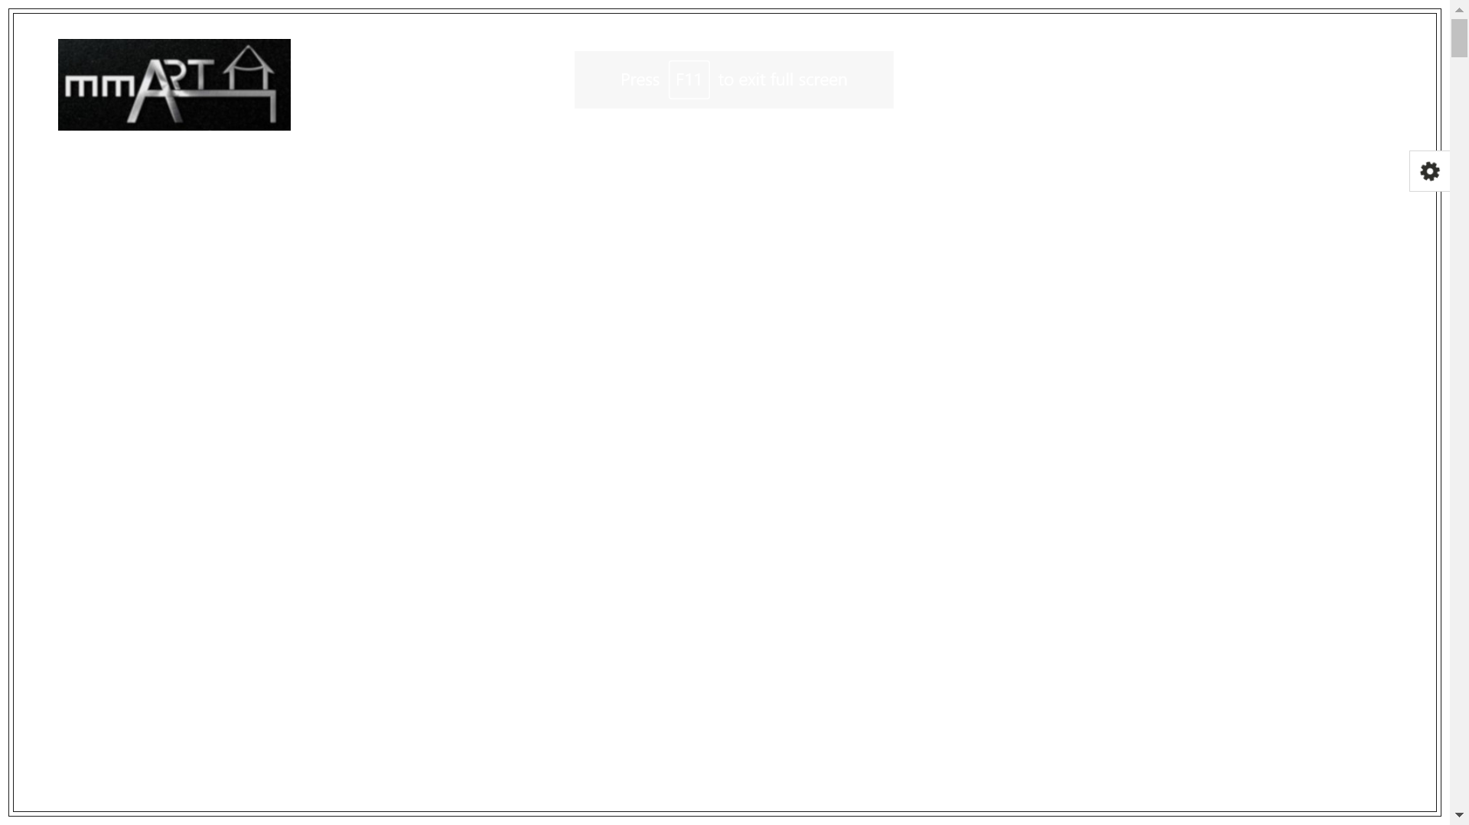

Change background colour to Ndi’s preference

Remove Twitter, put email address

Poster (Use image below with black border)

Move logo to the center

